

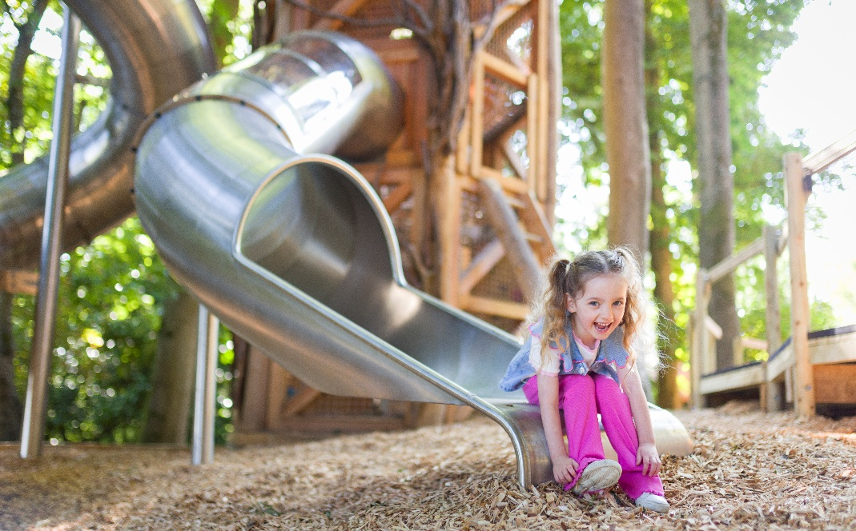

Wild Wood Adventure Playground now open at Waddesdon Manor
After 10 months in the making, Waddesdon Manor's spectacular new Wild Wood Adventure Playground is now open for families to enjoy, just in time for the school holidays (from Saturday 1 August 2026).
Nestled within woodland and inspired by the historic Manor, the new playground combines towers, tunnels, slides and swings with a series of imaginative play experiences designed for children aged 2 to 12.
Created by natural playground specialists TouchWood Play, who conducted a series of workshops with local community groups and schools in Buckinghamshire to help discover what children and families want to have in the new experience, the project has used more than 17 tonnes of sustainably sourced wood from five different tree species to create a one-of-a-kind adventure space.
Visitors can explore standout features including the Lost Mansion, an imaginative structure inspired by the Manor, the Plaviary treetop walkway - its name a direct reference to the famous and zoologically important Aviary in the Manor’s grounds, one of Europe’s smallest registered zoos.
They will also encounter a large wooden mynah bird (inspired by the Rothschild mynah, or Leucopsar rothschildi – which can be seen for real in the Aviary) and other Waddesdon Manor related animals, including a stick insect and Poupon, Waddesdon Manor’s founder Baron Ferdinand’s beloved and renowned poodle of that name.
Shaped by families for families, the playground has been designed to encourage adventure, imagination and connection with nature.
It has been funded by The Rothschild Foundation in recognition of the huge importance of family visits to Waddesdon Manor.
Joe Cooper, founder of TouchWood Play, says “When people use playgrounds nowadays, it’s no longer just a certain age group, it’s actually all ages and all abilities who seek to engage in play. We focused closely on providing a range of different entry-level experiences in play throughout the site, so the whole family can enjoy the adventure together.”
Pippa Shirley, Director of Waddesdon Manor says: “I am so excited the new playground is now open, bringing the garden and woodlands to life for children and families. TouchWood have been such collaborative partners and have helped us create something which could only be found here at the Manor – reflecting so much that is distinctive about our wonderful site. It’s also been completely inspiring to be part of a project specifically designed for and by our young visitors to bring them here and encourage them to play, to challenge themselves and simply to be in nature.
We all know, in our technologically dominated world, how important these moments are, and how important it is for families to connect and make their own unique memories. We’re all incredibly proud that the Wild Wood can play a part in that.”
In addition to the new playground, families will be able to enjoy a new woodland trail along Miss Alice’s Drive, as well as picnic areas, cafés and a wealth of family events throughout the summer.
Entry to Wild Wood Adventure Playground is included with a Grounds Entry ticket and is free to National Trust members.
For full details of everything that Waddesdon Manor has to offer for families, garden lovers and art fans – please visit the website.

HI-RES IMAGES OF WILD WOOD PLAYGROUND CAN BE FOUND HERE Wild Wood Adventure Playground Images
© Waddesdon Manor Image Library, Will Amlot
NOTES TO EDITORS
Two short film showing the playground's construction can be viewed here:
https://vimeo.com/reviews/d8de84d0-156a-4a39-bb95-843b54fa082c/videos/1214540425
https://vimeo.com/reviews/39f2ebf0-a806-40c3-b410-503b788ff83b/videos/1212602380
Waddesdon Manor - The Manor is a world where art, history and nature meet. Created from 1874 by Baron Ferdinand de Rothschild, the French-inspired chateau was built for beauty, for a collection, and for entertaining. Today its doors open wide to reveal masterpieces and curiosities, sweeping gardens, and hidden corners, stories that surprise and details that delight. The Manor is a living emblem of the work of the Rothschild Foundation: a family charitable trust active in the arts, community, nature and sustainability. In partnership with the National Trust, Waddesdon Manor is more than a historic house: it is a place of imagination and encounter, sustained and kept vibrant for each generation. A place to escape the everyday – a home for discovery and an inspiration for the world – where you can truly experience the extraordinary.
More at https://waddesdon.org.uk/about-us/press/notes-for-editors/ For more information on Waddesdon Manor and its exhibitions, visit www.waddesdon.org.uk, like @WaddesdonManor on Facebook, follow @WaddesdonManor on Twitter and @waddesdonmanor_nt on Instagram.
TouchWood Play is a leading creator of bespoke play environments that spark curiosity, creativity and connection with nature. With a strong focus on sustainability and innovative design, TouchWood Play works in partnership with heritage properties, visitor attractions and communities to transform outdoor spaces into extraordinary places to play. They are specialists in creating imaginative play spaces inspired by nature, we sensitively integrate play equipment into heritage settings, enhancing the visitor experience while preserving historic charm. www.touchwoodplay.com

FOR MORE INFORMATION
Tracy Jones, Brera PR – tracy@brera-london.com / 01702 216658 / 07887 514984 / www.brera-london.com

